Projectos Portugueses:

<https://www.vodafone.pt/press-releases/2007/8/sos-praias-diminui-sinistralidade-nas-praias-nao-vigiadas-do-concelho-de-mafra.html>

<https://www.oeiras.pt/-/sos-one-up-praias-santo-amaro-torre>

<https://cm-tvedras.pt/artigos/detalhes/sos-talking-na-praia-da-vigia>

Drones em Praias:

<https://www.youtube.com/watch?v=weNvQc2T33k>

[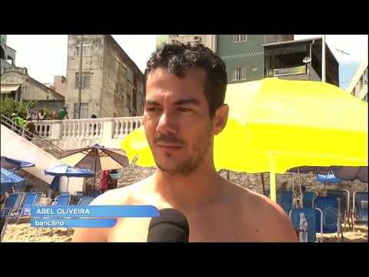](https://www.youtube.com/watch?v=weNvQc2T33k)

<https://www.youtube.com/watch?v=QwzHcoICDII>

[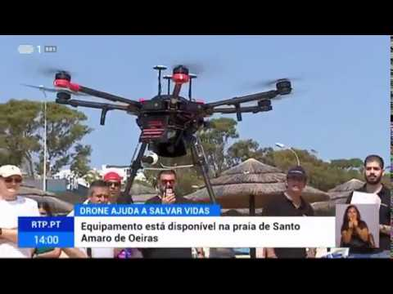](https://www.youtube.com/watch?v=QwzHcoICDII)

<https://www.facebook.com/municipio.espinho/videos/drone-na-praia/918825548623138/>

Mortes por afogamento (Observatório):

<https://observatoriodoafogamento.blogspot.com/2019/04/estatistica-de-afogamento-drowning.html>